Content

1. What is the micro:bit 2
2. Keyboardcontrol 3
3. Start Unplugged with the micro:bit 4
4. First project with the micro:bit 5
5. Download to the micro:bit 6
6. Button A – melody and tone 7
7. Shake and music 8
8. Make an animation with sound 9
9. Make a dice 11
10. Fortune Teller 13
11. Record and play 15
12. Connect 2 micro:bits 16
13. Send a secret code 18
14. Klick game with sound 20
15. Hot Potato game 22

What is the micro:bit

The BBC micro:bit is an award-winning programmable device that allows students to get hands-on with coding and digital making. Use it to inspire your students to recognise the power of technology in the real world.
It has more then seven sensors (sound, temperature, radio, accelerometer, shake etc). You can connect motors, LED’s etc with crocodile clips. It is fun te make something with the micro:bit
You can easly code the micro:bit in blockcode with https://makecode.microbit.org or with scripting with https://python.microbit.org/v/3.
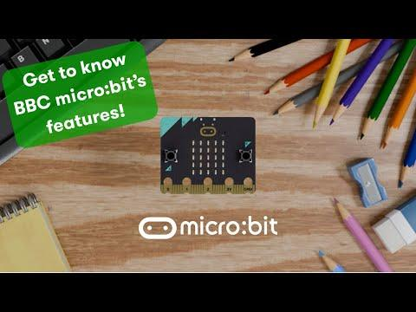
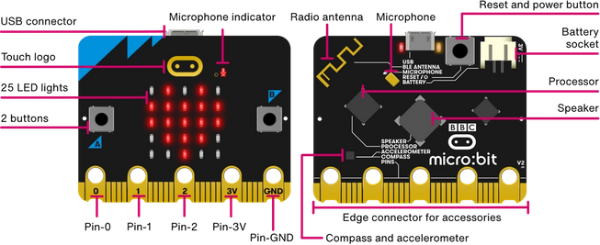

Keyboardcontrol
Since july 2025 there is keyboard control in the makecode website. Here is a short list of the important keys. Here is the documentation for Windows or Mac.

CONTROL + / = Show/hide shortcut help
CONTROL + B = Menu area
ARROWS = Navigation
T = Quickly to select the blocks
M = Move mode
W = Workspace
X = Disconnect blocks
F = Tidy up the workspace
ENTER or SPACE = Edit or confirm
HOLD CONTROL = Move
CONTROL + C = Copy
CONTROL + V = Paste
CONTROL + X = Delete
DELETE or BACKSPACE = Delete a block
CONTROL + ENTER = Context menu
CONTROL + Z = Undo
CONTROL + ARROWS = Move the blocks
TAB + SHIFT TAB = Move between menus, simulator and the workspace
CONTROL + Z = Undone
ESCAPE = Cancel
TAB = Move big steps
CONTROL + B + 1 + TAB = Tab until settings
CONTROL + B + 3 + UP = Search for a block

Start Unplugged with the micro:bit
To start off with the micro:bit, it is a good idea to start off with a big micro:bit so everybody can feel and see what there is on the micro:bit.
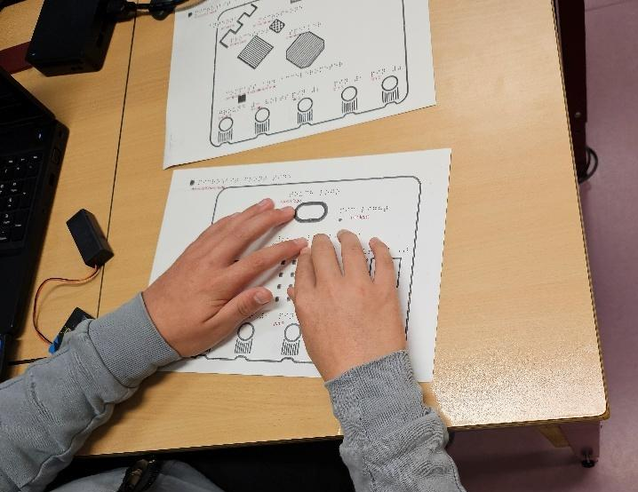
Also a good idea is start off with unplugged coding of the blocks. You have to put the code together like jigsaw blocks. You can print the blocks yourself.
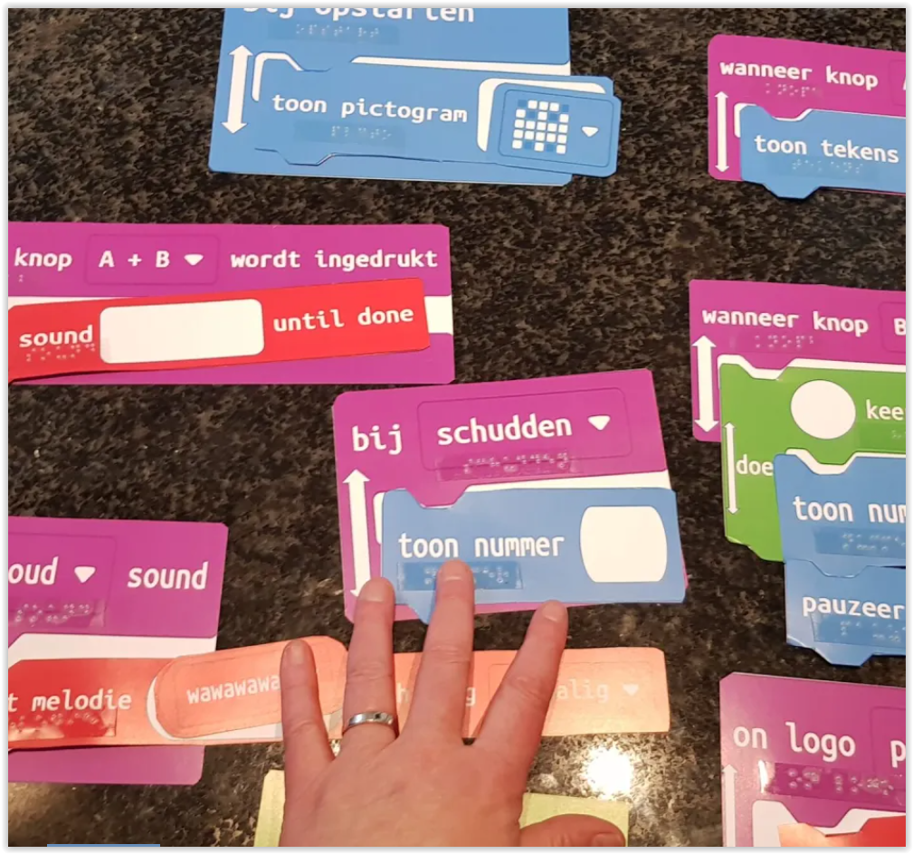

First project with the micro:bit
You will start with pressing button A and B to get some sound out of your micro:bit.
STEPS
Go to https://makecode.microbit.org
- TAB + ENTER to reach for new project.
- TYPE a name Give your project a name.
- ENTER The project is made.
- CONTROL + / Activate keyboard control.

- T Go to the blocks menu.
- ARROWS Go to Music.
- ARROW RIGHT Select the Music.
- ARROWS Go to Play tone.
- ENTER Select this block.
- LEFT + ENTER Put this blokc in the on start block.

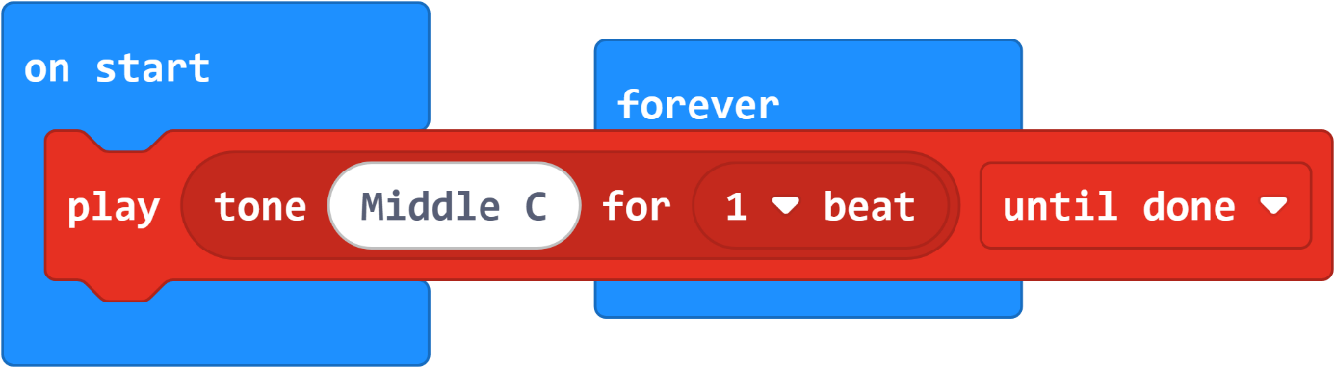
PICTURE OF THE CODE

MAKE YOUR OWN
Put in an other play tone, in the forever block. What will happen?

LINK TO THE PROJECT
https://makecode.microbit.org/_4si2pai0AcsT

Download to the micro:bit
Now you will download your code to the micro:bit. The first time you do this, you have to connect the micro:bit to your computer. But when that is done, the dowloading is very easy.
STEPS
- Get your micro:bit
- Connect the usbc kabel to the micro:bit (can only be done in the middle)
- Connect the other side to your computer
- You will hear a sound that your micro:bit is connected

- CONTROL + B + 5 To go to the Menu area for downloading.
- TAB + ENTER To get to the screen for connect with the micro:bit.
- TAB + ENTER Yes, I want to connect with the micro:bit.
- TAB + ENTER Yes, I want to pair this micro:bit.
- SELECT Ask you teacher, to help with select the right micro:bit (a bug).

- CONTROL + B + 5 Go to the Menu area for downloading.
- ENTER Your code is being downloaded to your micro:bit.
You will hear the micro:bit now give youre tone.
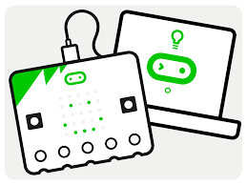

Button A – melody and tone
Now you will put more code on your micro:bit. You will make a Button A with a some music.
STEPS
- T Go to the blocks menu.
- ARROWS Go Input.
- ARROW RIGHT Select Input.
- ARROWS Go to on button A pressed.
- ENTER + ENTER Select this block and put this block in your Workspace.

- T Go to the blocks menu.
- ARROWS Go Music.
- TAB Select Music.
- ARROWS Go to on Play Melody.
- ENTER + ENTER Select this block and put this block in your Workspace.

- ENTER + TABS You can make your own tune or pick one from the gallery.
- TABS You can listen to you song.

- CONTROL + B + 5 Go to the Menu area for downloading.
- ENTER Your code is being downloaded to your micro:bit.
- PRESS A Press A on your micro:bit and listen to your song.

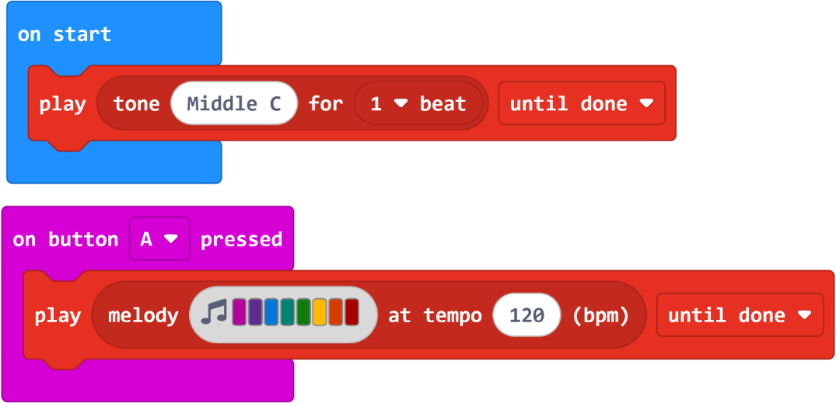
PICTURE OF THE CODE

MAKE YOUR OWN
Make now your own button B with sound. Of course you have to change the A into B because you can only have 1 input Button A.
LINK TO THE PROJECT
https://makecode.microbit.org/_Ypo5TYLk3F38

Shake and music
Now you will use the Shake function on the micro:bit.
STEPS
- T Go to the blocks menu.
- ARROWS Go Input.
- ARROW RIGHT Select Input.
- ARROWS Shake.
- ENTER + ENTER Select this block and put this block in your Workspace.

- T Go to the blocks menu.
- ARROWS Go Music.
- TAB Select Music.
- ARROWS Go to Play giggle. (all the way down)
- ENTER Select this block.
- LEFT + ENTER Put this block in your on shake.

- ARROW RIGHT You go to the select music part.
- ENTER Go to the play part
- ARROW + ENTER Select an other play music.

- CONTROL + B + 5 Go to the Menu area for downloading.
- ENTER Your code is being downloaded to your micro:bit.
- SHAKE Shake your micro:bit to hear you music.
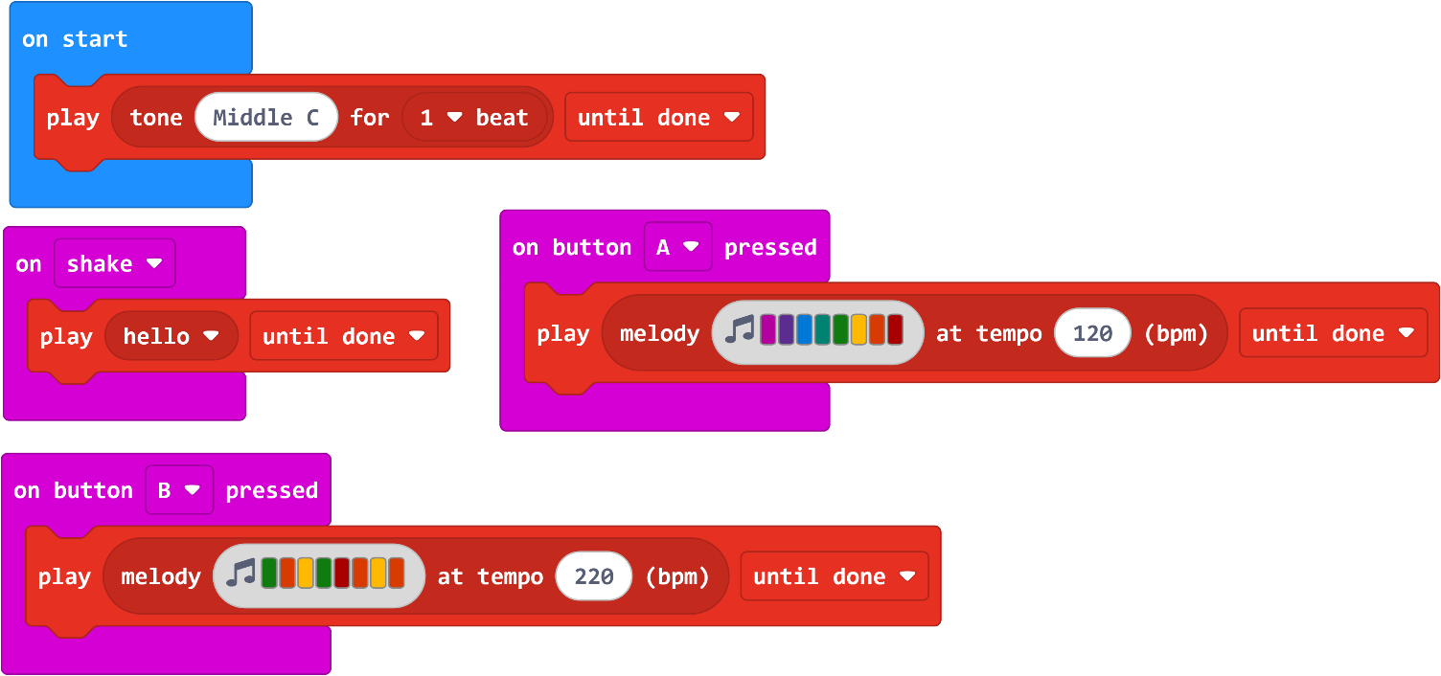
PICTURE OF THE CODE

MAKE YOUR OWN
Try other music tones, or also the input A+B.
LINK TO THE PROJECT
https://makecode.microbit.org/_P1p9VUA0hDi8

Make an animation with sound
Now you are going to make an animation with sound and pictures. You will use the repeat and button A. First you are going to delete all the blocks, and start all over.
STEPS
- W Go to the Workspace.
- CONTROL + ENTER The context comes up.
- ARROWS + ENTER Select Delete All Blocks.
- TAB + ENTER Yes, I want to delete all the blocks

- T Go to the blocks menu.
- ARROWS Go to Input.
- ARROW RIGHT Select on button A pressed.
- ARROWS Go to on button A pressed.
- ENTER + ENTER Select this block and put this block in your Workspace.

- T Go to the blocks menu.
- ARROWS Go Loops.
- ARROW Go to repeat 4 times.
- ENTER + LEFT Select this block and put this in de on button A pressed.

- T Go to the blocks menu.
- ARROWS Go to Basic
- ARROW + ENTER Go to show icon, and put this in the Workspace
- LEFT + ENTER Move it in the repeat 4 times.
- ARROW + DOWN Change the icon.
- CONTROL + C Copy the block show icon.
- CONTROL + V Paste the block show icon.
- M + ARROW LEFT Move the new block under the show icon.
- ARROWN + DOWN Change the icon.

- T Go to the blocks menu.
- ARROWS Go to Music.
- ARROW + ENTER Go to Play tone.
- LEFT + ENTER Move it under the first show icon.
- CONTROL + C Copy the block play tone.
- CONTROL + V Paste the block play tone.
- M + ARROW LEFT Move the new block under the second show icon.
- ARROWN + DOWN Change the music tone.

- CONTROL + B + 5 Go to the Menu area for downloading.
- ENTER Your code is being downloaded to your micro:bit.
- PRESS A Your animation is and your sound is coming.

PICTURE OF THE CODE
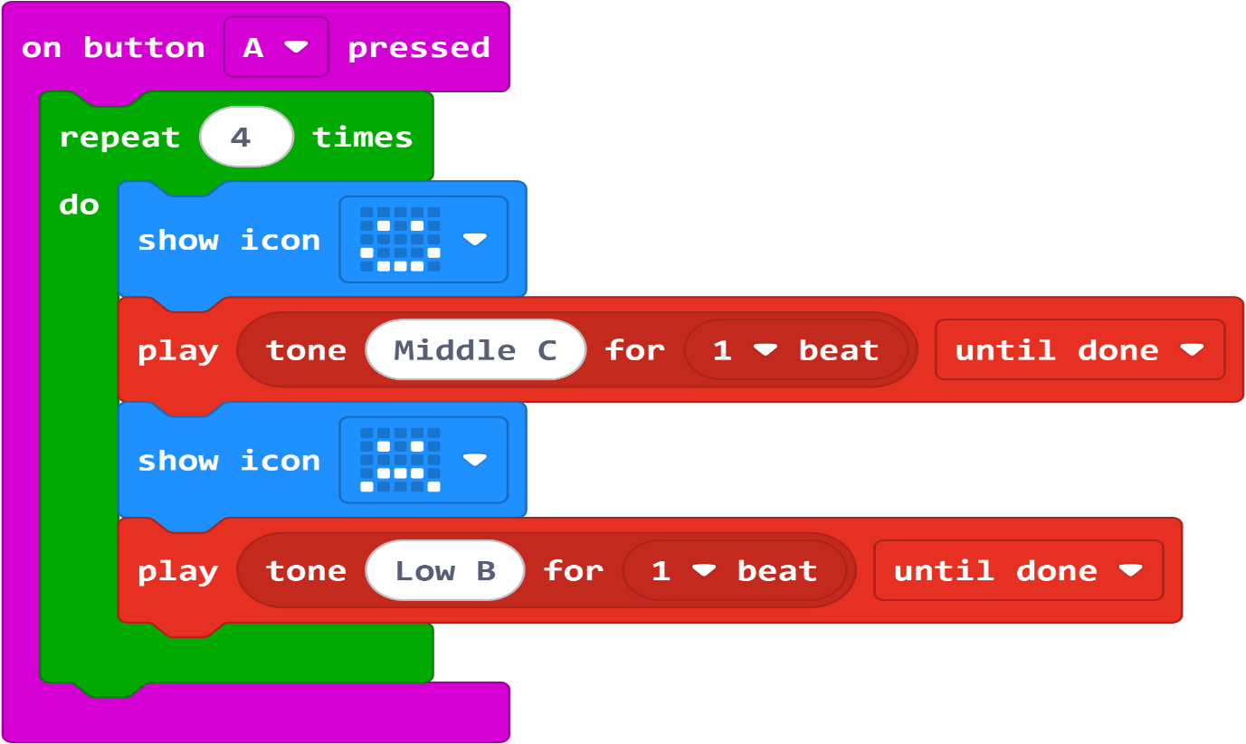

MAKE YOUR OWN
You can make your own piece of music. Try it in on button B pressed. Here is an example to make a small piece of Harry Potter music.
- play tone 330 for 1 beat
- play tone 440 for 1 beat
- play tone 523 for 1 beat
- play tone 494 for ½ beat
- play tone 440 for ½ beat
- play tone 659 for 1 beat
- play tone 587 for 1 beat
- play tone 494 for 1 beat

LINK TO THE PROJECT
https://makecode.microbit.org/_csXXpwXch3gP

Make a dice
Now you are going to make a dice with the micro:bit. As you shake the micro:bit he will random pick a number between 1 and 6, and you will hear a tone as many times of the random picked number. First you are going to delete all the blocks, and start all over. As you have done some projects already, the descriptions are shorter.
STEPS
- W Go to the Workspace. And delete all the blocks.

- T + ARROWS Go to the blocks menu and go to the Input.
- ARROWS + ENTERS Go to Shake and select this block and put this in your Workspace.

- T + ARROWS Go to the blocks menu and go to Variables.
- ARROWS RIGHT Select Make new variables call this variable DICE.
- ARROW DOWN Select this block and put this in SHAKE.

- T Go to the blocks menu.
- ARROW UP Your are I the search.
- PICK Type pick, he will look for the block pick random.
- ENTER Select this block and put this in the 0 of the dice to 0.
- ENTER Change the numbers 1 and 6. (he will random change the numbers).

- T + ARROWS Go to the blocks menu, go to Loops.
- ARROWS + ENTER Go to repeat 4 times, select this block and put this under set dice.

- T + ARROWS Go to the blocks menu and go to Music.
- ARROWS + ENTERS Go to play tone, select this block and put this in repeat 4 times.

- T + ARROWS Go to the blocks menu and go to Basic.
- ARROWS + ENTERS Go to show Number, select this block and put this under play tone.

- T + ARROWS Go to the blocks menu, and go to Variables.
- ARROWS + ENTERS Go to the variable dice, select this block and put this in the repeat block.

- T + ARROWS Go to the blocks menu and go to Variables.
- ARROWS + ENTER Go to variables dice, select this block and put this in the show number.

- T + ARROWS Go to the blocks menu, go to Basic.
- ARROWS + ENTER Go to pause, select this block and put it under show number.

- CONTROL + B + 5 Go to the Menu area for downloading.
- ENTER Your code is being downloaded to your micro:bit.
- SHAKE Shake your micro:bit and you hear how much the dice is.

PICTURE OF THE CODE
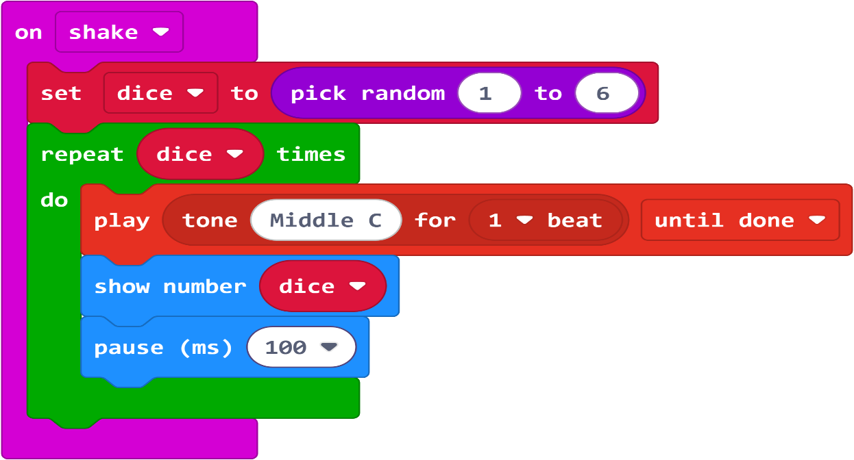

MAKE YOUR OWN
What can you change, to make the tones come quicker or use other tones, or more numbers on the dice.

LINK TO THE PROJECT
https://makecode.microbit.org/_1cPLLM4Athxd

Fortune Teller
Now you are going to make a fortune teller. You can ask a question and if you shake the micro:bit he will react with a smile and high tone (as a yes) and a sad face and low tone (as a no). First you delete all the blocks, and start all over.
STEPS
- W Go to the Workspace. And delete all the blocks.

- T + ARROWS Go to the blocks menu and go to the Input.
- ARROWS + ENTERS Go to Shake and select this block and put this in your Workspace.

- T + ARROWS Go to the blocks menu, go to Logic.
- ARROWS + ENTERS Go to the if true else block, select this block and put it in the shake block.

- T + ARROWS Go to the blocks menu, go to Music.
- ARROWS + ENTERS Go to play tone, select this block and put it in the top of if true else block.
- ARROWS + ENTER Change this tone of your music block in a high tone.
- CONTROL C Copy this play tone block.
- CONTROL V Paste this play block in the second if true else block.
- ARROWS + ENTER Change this tone in a low tone.

- T + ARROWS Go to the blocks menu, go to Basic.
- ARROWS + ENTERS Go to the show icon, select this block, put it under the first sound block.
- ARROWS + ENTER Change the icon in a smile.
- CONTROL C Copy this icon block.
- CONTROL V Paste this icon block en put it in the second if true else block.
- ARROWS + ENTER Change this icon in a sad face.

- CONTROL + B + 5 Go to the Menu area for downloading.
- ENTER Your code is being downloaded to your micro:bit.
- SHAKE If you ask a question. For instance is it good weather tomorrow, the
micro:bit will give you an answer in yes (high tone and smiley face) of no (low tone and sad face).

PICTURE OF THE CODE
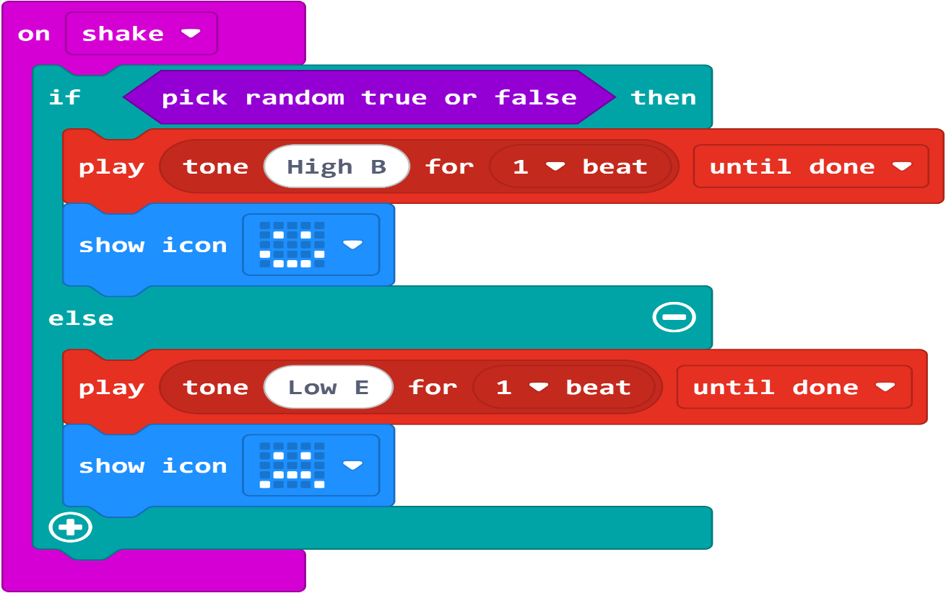

MAKE YOUR OWN
What kind of questions can you ask more. What kind of blocks can you add, to make it more fun.

LINK TO THE PROJECT
https://makecode.microbit.org/_R8eLrsWCbVgY

Record and play
Now you are going to add an extra block, so you can record and play a sound. This are new blocks, so they are not very good yet, but it is fun to do. First you are going to delete all the blocks, and start all over.
STEPS
- W Go to the Workspace. And delete all the blocks.
- T Go to the blocks menu.
- ARROWS Go to Extensions. An other site will open, with extra blocks.
- TAB Go to the Record blocks.
- ENTER Your are back at the “normal” editor and now the Record block is there.

- T + ARROWS Go to the blocks menu, go to Input.
- ARROWS + ENTER Go to on button A pressed, and put this in the Workspace.
- T + ARROWS Go to the blocks menu, go to Record.
- ARROWS+ ENTER Go to record audio clip, and put this in on button A pressed.

- T + ARROWS Go to the blocks menu, go to Input.
- ARROWS + ENTER Go to on button B pressed, and put this in the Workspace.
- ARROWS + ENTER Change the button A in B.
- T + ARROWS Go to the blocks menu, go Record.
- ARROW + ENTER Go to play audio clip, and put this in on button B pressed.

- CONTROL + B + 5 Go to the Menu area for downloading.
- ENTER Your code is being downloaded to your micro:bit.
- PRESS A To record a message as long as the light is on.
- PRESS B To listen to your message.

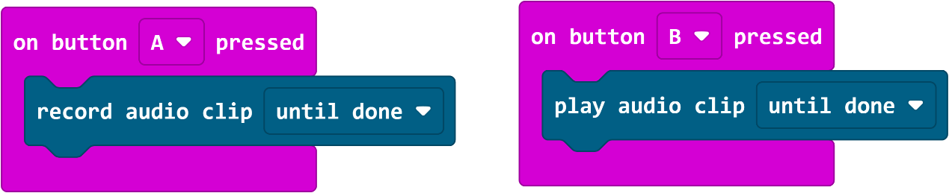
PICTURE OF THE CODE

MAKE YOUR OWN
How long is the audio clip you can record? Try it out.
LINK TO THE PROJECT
https://makecode.microbit.org/_e45fstev6Tva

Connect 2 micro:bits
You can connect micro:bits if you put them on the same radio channel. So agree on a radio channel, to work together. There can be 70 meter in between (without thick walls). First you are going to delete all the blocks, and start all over.

STEPS
- W Go to the Workspace. And delete all the blocks.
- T + ARROWS Go to the blocks menu, go to Basic.
- ARROWS + ENTER Go to on start, select the block and put it in the Workspace.

- T + ARROWS Go to the blocks menu, go to Radio.
- ARROWS + ENTERS Go to radio set group , select this block and put it the on start block.

- T + ARROWS Go to the blocks menu, go to Input.
- ARROWS + ENTERS Go to button A , select this block and put it the Workspace.
- T + ARROWS Go to the blocks menu, go to Radio.
- ARROWS + ENTERS Go to radio send number , select this block and put in Button A pressed.
- T + ARROWS Go to the blocks menu, go to Basic.
- ARROWS + ENTERS Go to show icon , select this block and put under radio send.
- ARROWS + TAB Select an icon.

- T + ARROWS Go to the blocks menu, go to Radio
- ARROWS + ENTERS Go to radio received number, select this block and put it the Workspace.
- T + ARROWS Go to the blocks menu, go to Music.
- ARROWS + ENTERS Go to play melody , select this block and put in on radio received.
- ARROWS + TAB Select an icon.

- CONTROL + B + 5 Go to the Menu area for downloading.
- ENTER Your code is being downloaded to your micro:bit.
- PRESS A The other micro:bit will react with the melody.

PICTURE OF THE CODE
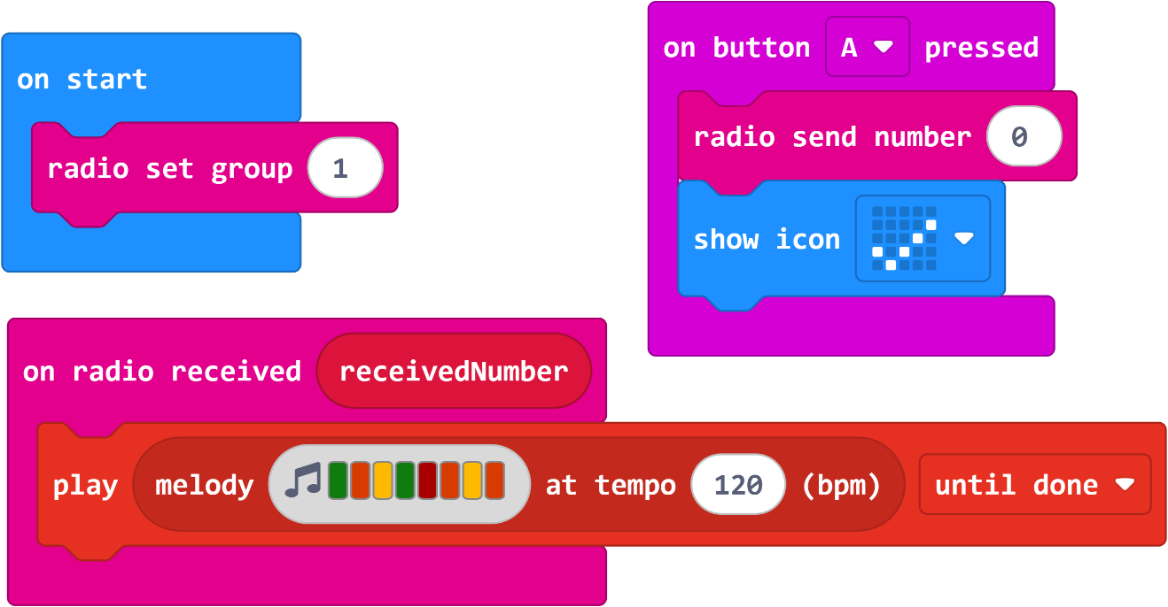

MAKE YOUR OWN
You can get an other sound, when you received a number. This is often used to control a car with a micro:bit and an other micro:bit as a remote control.

LINK TO THE PROJECT
https://makecode.microbit.org/_Tv9DJ998aEgT

Send a secret code
As you saw in project 13, you can connect micro:bits and send a number. You can also send a text, then you can send a secret code to each other.
If you put them on the same radio channel. So agree on a radio channel, to work together. There can be 70 meter in between (without thick walls). You will not delete all the blocks, you will keep the on start block. The other you can delete.

STEPS
- W Go to the Workspace. Delete only button A and received a number.
- T + ARROWS Go to the blocks menu, go to Input.
- ARROWS + ENTER Go to on button A pressed, select the block and put it in the Workspace.

- T + ARROWS Go to the blocks menu, go to Radio.
- ARROWS + ENTERS Go to radio send string , select this block and put it the on button A block.
- ARROWS + ENTERS Change the string in YES (or something else).
- CONTROL C Copy on button A pressed.
- CONTROL V Paste on button A pressed.
- ARROWS + ENTER Change button A pressed into B pressed.
- ARROWS + ENTERS Change the text YES in No (or something else).

- T + ARROWS Go to the blocks menu, go to Radio.
- ARROWS + ENTERS Go to radio received string, select this block and put it the Workspace.
- T + ARROWS Go to the blocks menu, go to Basic.
- ARROWS + ENTERS Go to show string , select this block and put in radio received string.
- CONTROL C Copy on the word received string from the block received string.
- CONTROL V Paste the received string, put this in the show string on “Hello”.

- CONTROL + B + 5 Go to the Menu area for downloading.
- ENTER Your code is being downloaded to your micro:bit.
- PRESS A The other micro:bit will get your message A. (YES)
- PRESS B The other micro:bit will get your message B. (NO)

PICTURE OF THE CODE
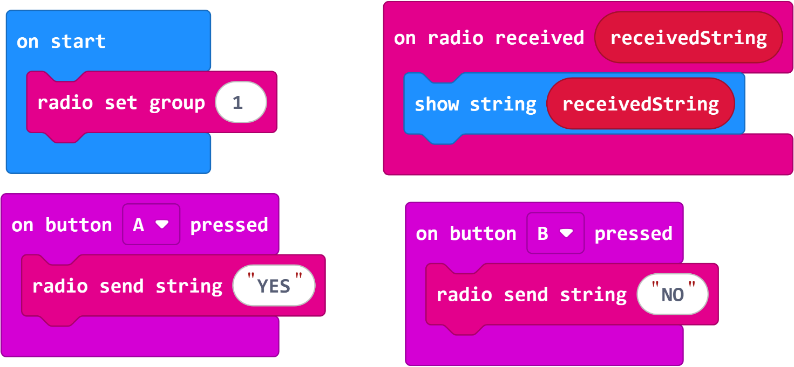
MAKE YOUR OWN
What else can you send, try how far away you can stand with you micro:bits.

LINK TO THE PROJECT
https://makecode.microbit.org/_iR7cdeXD75EP

Klick game with sound
Now you are going to make a simple klick game with sounds. Klick on button A and a LED light will go on and you hear a sound. When you fill all the LED’s before the time is over you win. You can play this against each other. Or you can hack the game….
STEPS
- W Go to the Workspace. Delete all the blocks.

- T + ARROWS Go to the blocks menu, go to Input.
- ARROWS + ENTER Go to on button A pressed, select the block and put it in the Workspace.

- T + ARROWS Go to the blocks menu, go to Led.
- ARROWS + ENTERS Go to plot x y , select this block and put it the on button A block.
- T + ARROWS Go to the blocks menu, go to Math.
- ARROWS + ENTERS Go to pick random , select this block and put it the 0 of plot x.
- ARROWS + ENTERS Change the second 0 to 4 (then random he will put a LED on).
- CONTROL C Copy on pick random 0,4.
- CONTROL V Paste this one 0 of y.

- T + ARROWS Go to the blocks menu, go to Music.
- ARROWS + ENTERS Go to play tone, select this block under plot x,y.
- ARROWS + ENTERS Change the 1 beat in 1/16 beat.

- T + ARROWS Go to the blocks menu, go to Input.
- ARROWS + ENTERS Go to shake , select this block and this in the Workspace.
- T + ARROWS Go to the blocks menu, go to Basic.
- ARROWS + ENTERS Go to clear screen, select this block and put this in the shake block.
- T + ARROWS Go to the blocks menu, go to Extensions, Game.
- ARROWS + ENTERS Go to start countdown, select this block and put it under clear screen.
- T + ARROWS Go to the blocks menu, go to Music.
- ARROWS + ENTERS Go to play tone, select this block and this under start countdown.
- ARROWS + ENTERS Change tone to high B.

- CONTROL + B + 5 Go to the Menu area for downloading.
- ENTER Your code is being downloaded to your micro:bit.
- SHAKE Your klick game will start, you can start Pressing A when you hear high.
- PRESS A A LED light will go on, and you will hear a sound. Try to click quickly
before the time is up. Play it with somebody else who also made the
game. Who filled up all the LED lights has won.
- PRESS RESET To restart the game. At the back of the micro:bit there is a small button
between the battery block and the usb connection. You can play again.

PICTURE OF THE CODE
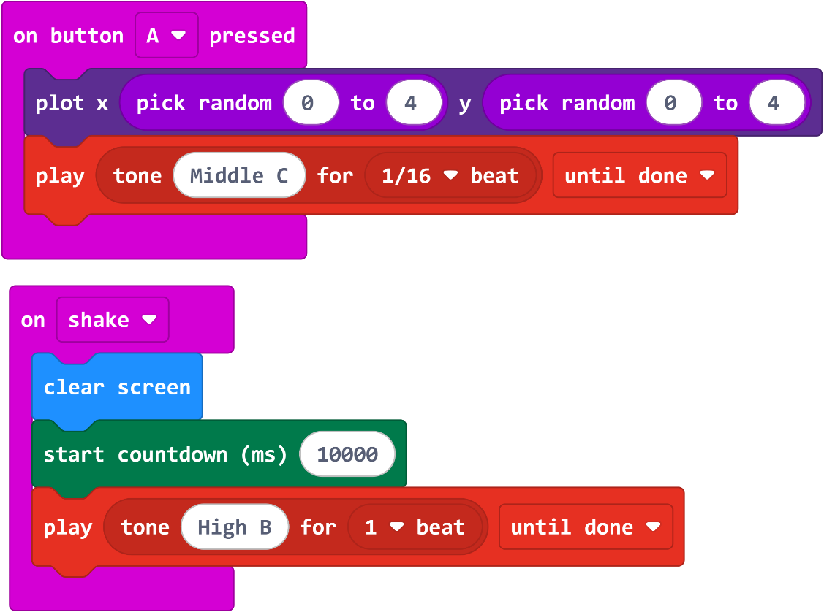

MAKE YOUR OWN
How can you hack this game? Can you put the countdown higher, can you plot more LED’s when you press A. How can you delete a LED on the other micro:bit by using the radio? Have fun.

LINK TO THE PROJECT
https://makecode.microbit.org/_3vkWY1b8KAuq

Hot Potato game
Do you know the game “Hot Potato” with a time “bomb”. You have to hand it to the other person in a circle, when the “bomb” explode you loose. You will make this with the micro:bit.

STEPS
- W Go to the Workspace. Delete only button A and received a number.
- T + ARROWS Go to the blocks menu, go to Input.
- ARROWS + ENTER Go to on shake, select the block and put it in the Workspace.

- T + ARROWS Go to the blocks menu, go Basic.
- ARROWS + ENTERS Go to show string , select this block and put it the on shake block.
- ARROWS + ENTERS Change the string in 3 2 1 (a countdown).
- T + ARROWS Go to the blocks menu, go Variables.
- ARROWS + ENTERS Go to make a Variables, time.
- ARROWS + ENTER Select set time to 0, put this under the show string in shake.
- T + ARROWS Go to the blocks menu, go Math.
- ARROWS + ENTERS Go to pick random , select this block and put it the 0 from set time.
- ARROWS + ENTERS Change the pick random to 5 to 20.

- T + ARROWS Go to the blocks menu, go to Loops.
- ARROWS + ENTERS Go to while false do, select this block and put under the set time.
- T + ARROWS Go to the blocks menu, go to Basic.
- ARROWS + ENTERS Go to Logic , select the block 0 = 0 and put this in the false block.
- T + ARROWS Go to the blocks menu, go Variables..
- ARROWS + ENTERS Go to time, select this block and put this in the first 0 of the logic block.
- ARROWS + ENTERS Change the = to > in this block.

- T + ARROWS Go to the blocks menu, go to Music.
- ARROWS + ENTERS Go to play tone, select this block into while do.
- ARROWS + ENTERS Change the 1 beat to 1/4 beat.
- T + ARROWS Go to the blocks menu, go to Variables.
- ARROWS + ENTERS Go to change time , select this block and put it under the play tone.
- ARROWS + ENTERS Change the 1 into -1
- T + ARROWS Go to the blocks menu, go to Basic
- ARROWS + ENTERS Go to pause, select this block and put it under the change time.

- T + ARROWS Go to the blocks menu, go to Music.
- ARROWS + ENTERS Go to play, select this block and put it under the while do
- ARROWS + ENTERS Change the play song into sad.

- CONTROL + B + 5 Go to the Menu area for downloading.
- ENTER Your code is being downloaded to your micro:bit.
- SHAKE Your bomb starts counting down.

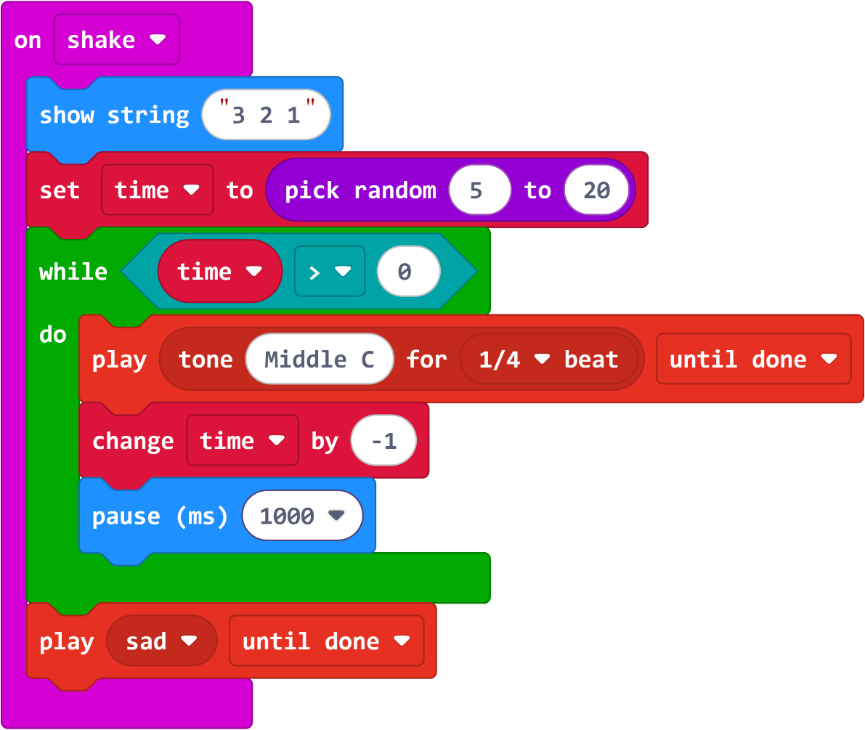
PICTURE OF THE CODE

MAKE YOUR OWN
What else can you do with this code. Can you also random change the pause? How can you change the tone that when the time is there, the sound is coming quicker? Can you also show something on the LED’s. Will that make the game more exiting?

LINK TO THE PROJECT
https://makecode.microbit.org/_fK0PdCg7ufHw

